Joining a Zoom meeting on Android
- Open the Zoom mobile app. If you have not downloaded the Zoom mobile app yet, you can download it from the Google Play Store. See below for instructions.
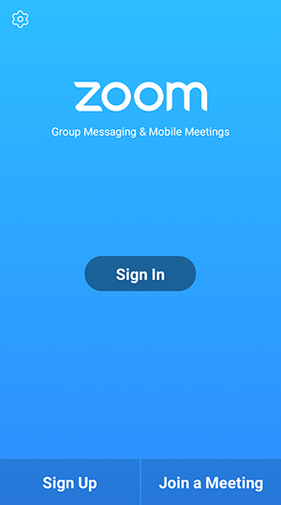
Tap Join a Meeting

When you’re ready, tap on Join Meeting. It should be a darker blue
Don’t touch these
You can change the name by tapping here
Enter the meeting ID number (sent in an email) by tapping here

Downloading App from Playstore

Downloading Apps
Go to the Google Play Store
Tap on the Search box or on the microphone. Type ZOOM Cloud Meetings

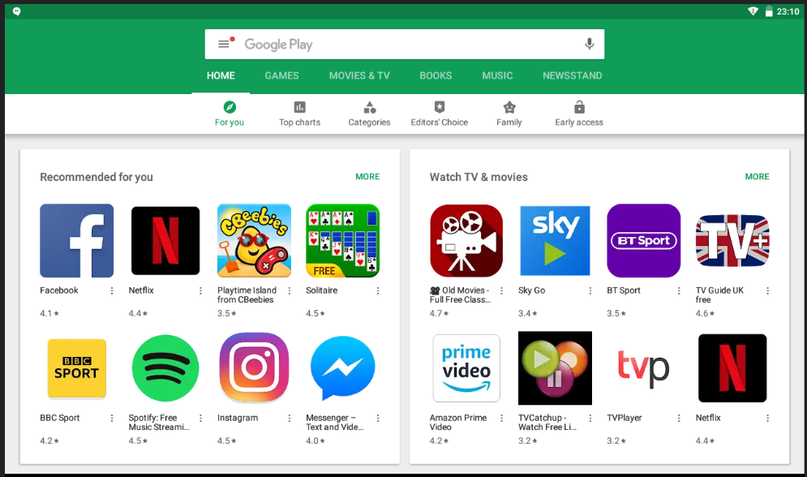
When you find the app you want to download, tap on Install.

