Using a browser

Google Chrome
- Open Chrome.
- Go to join.zoom.us.
- Enter your meeting ID provided by the host/organizer.
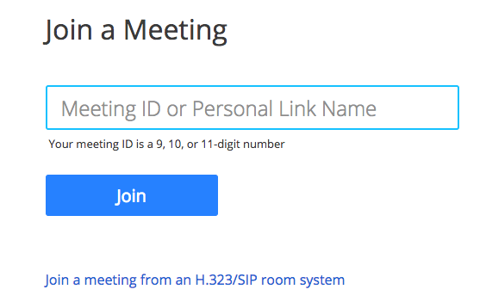
- Click Join.
- If this is your first time joining from Google Chrome, you will be asked to open the Zoom client to join the meeting.
- You can check Always open these types of links in the associated app to skip this step in the future.
- Click Open Zoom Meetings (PC) or Open zoom.us (Mac).

Safari (Apple only)
- Open Safari.
- Go to join.zoom.us.
- Enter your meeting ID provided by the host/organizer.
- Click Join.
- When asked if you want to open zoom.us, click Allow.

Microsoft Edge or Internet Explorer
- Open Edge or Internet Explorer.
- Go to join.zoom.us.
- Enter your meeting ID provided by the host/organizer.
- Click Join.

